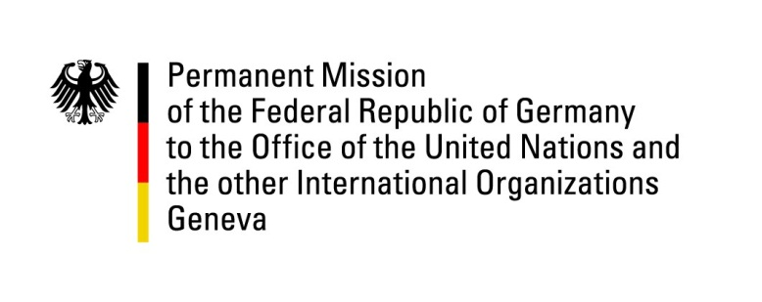

United Nations Human Rights Council
25th Session of the UPR Working Group
Geneva, 2 May 2016

---
German recommendations to Suriname

Mr. President,
Germany warmly welcomes the delegation of Suriname to the 25th session of the UPR. Germany commends Suriname for abolishing the death penalty in the Criminal Code. We look forward to its complete abolition by a reform of the Military Penal Code.
Germany remains concerned that implementation of two judgements of the Inter-American Court of Human Rights, pretrial detention and children’s rights require further attention. Germany would like to offer the following recommendations:
- Ensure that the judgements of the Inter-American Court of Human Rights regarding the Moiwana Community and Saramanka People are swiftly and completely implemented.
- Improve the conditions in pretrial detention facilities.
- Improve the protection of children. Strengthen early detection and counsel for victims of child sexual abuse. Raise public awareness about the harmful effects of corporal punishment.

Thank you, Mr. President.

